DSA06 – DATA HANDLING AND VISUALIZATION
ASSIGNMENT – VISUALIZING DATA

Name: SASI REKHA K
Reg. No: 192424010
Course code: DSA0602

Q1. Visual to Table: Reading a Colour Scale
(a) Reconstruct the 4 × 4 table
Subject | Test 1 | Test 2 | Test 3 | Test 4
Maths | 60–80 | 80–100 | 0–20 | 80–100
Physics | 60–80 | 80–100 | 60–80 | 0–20
Chem | 60–80 | 80–100 | 0–20 | 20–40
English | 0–20 | 20–40 | 20–40 | 80–100

(b) Name the type of colour scale and justify it.
The colour scale is sequential. The colours change from light to dark according to the pass score. Light colours represent lower values, while darker colours represent higher values.
(c) Name the cell(s) in the highest class and explain why darker = higher is intuitive.
The highest class is 80–100. It occurs at Maths–Test 2, Maths–Test 4, Physics–Test 2, Chemistry–Test 2 and English–Test 4. Darker colours are intuitive for higher values because stronger colour intensity attracts attention and can represent greater magnitude.
Q2. Design Decision: Choosing Aesthetics and a Colour Palette
(a) State the data type of each variable.
Variable | Data Type
Service_Rating | Ordinal
Avg_Wait_Min | Continuous
Hospital_Type | Nominal
Doctors | Discrete

(b) Assign a suitable aesthetic and scale type.
Variable | Aesthetic | Scale Type
Avg_Wait_Min | X-axis | Continuous
Doctors | Y-axis | Continuous / Discrete numeric
Hospital_Type | Colour | Discrete
Service_Rating | Size / Shape | Ordinal

(c) For the colour variable, name the palette type and give a suitable palette.
Hospital_Type is a qualitative/discrete colour variable. A suitable palette is:
scale_colour_brewer(palette = "Dark2")
This is suitable because hospital types are categories and there is no numerical order between them.
(d) Two steps to keep the chart readable for colour-blind viewers.
1. Use a colour-blind-safe palette, such as Dark2.
2. Use different shapes or labels along with colour so categories can be distinguished without relying only on colour.
Q3. Visual to R Code: Aesthetics and a Log Axis
(a) Write the complete R program.
library(ggplot2)
df <- data.frame(
City = c("Erode", "Vellore", "Tirupur", "Chennai",
"Trichy", "Theni", "Madurai"),
Literacy_pct = c(70, 80, 85, 80, 75, 70, 60),
Population_K = c(10, 50, 500, 1000, 10000, 20000, 5000),
Zone = c("South", "West", "East", "South",
"East", "West", "West")
)
ggplot(df, aes(x = Literacy_pct,
y = Population_K,
colour = Zone)) +
geom_point(size = 3) +
scale_y_log10() +
labs(
x = "Literacy_pct",
y = "Population_K (log scale)"
)
Output:
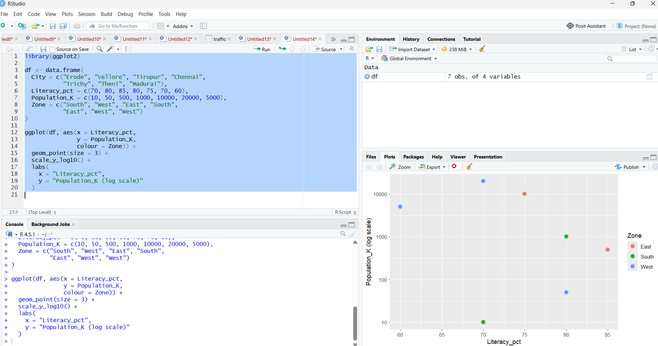

(b) Why does Population_K need a nonlinear axis?
The values of Population_K range from 10 to 20,000, which is a very large range. If a normal linear scale is used, the smaller values will be compressed near zero. Therefore, a logarithmic scale is used to display both small and large population values clearly.

Q4. Table to Visual: Colour as a Tool to Highlight
(a) State what must be highlighted and why highlighting helps the reader.
The department with the highest Placement_pct is MECH with 90%. It should be highlighted because it has the highest placement percentage.
(b) Bar chart data
Department | Placement_pct | Display
CSE | 60 | Other colour
CIVIL | 55 | Other colour
EEE | 75 | Other colour
IT | 70 | Other colour
ECE | 50 | Other colour
MECH | 90 | HIGHLIGHT
BIO | 85 | Other colour

For the chart, use MECH as the highlighted bar (for example, orange #E69F00) and use grey for the other departments. Add the value 90% above the MECH bar.
(c) Name the colour-scale type used and explain.
The colour is an accent/highlight colour. It is used to draw attention to one particular department rather than representing a continuous range of values.
(d) Suggest one way to keep the highlight visible for colour-blind readers.
Use a colour-blind-safe highlight colour and add a data label such as 90% or a different bar outline/pattern. Therefore, the highlighted department can still be identified without depending only on colour.
Q5. R Code to Visual: Aesthetics and a Log Axis
(a) Identify what the chart produces: axes, point positions and the legend.
The program produces a scatter plot.
• X-axis: Population_K
• Y-axis: Literacy_pct
• Colour: Zone
• Point size: 3
• X-axis: Logarithmic scale
City | Population_K | Literacy_pct | Zone
Trichy | 20 | 65 | South
Chennai | 100 | 65 | East
Karur | 10 | 85 | North
Salem | 200 | 90 | North
Vellore | 500 | 75 | North
Theni | 50 | 65 | North
Tirupur | 2000 | 55 | East

(b) State the aesthetic and scale type used for each variable.
Variable | Aesthetic | Scale
Population_K | X-axis | Continuous, log10
Literacy_pct | Y-axis | Continuous, linear
Zone | Colour | Discrete qualitative
Points | Size | Fixed size = 3

(c) Rewrite one line so the points use a colour-blind-safe palette.
scale_colour_brewer(palette = "Dark2")
ggplot(df, aes(x = Population_K,
y = Literacy_pct,
colour = Zone)) +
geom_point(size = 3) +
scale_x_log10() +
scale_colour_brewer(palette = "Dark2") +
labs(x = "Population_K (log scale)")
Output:
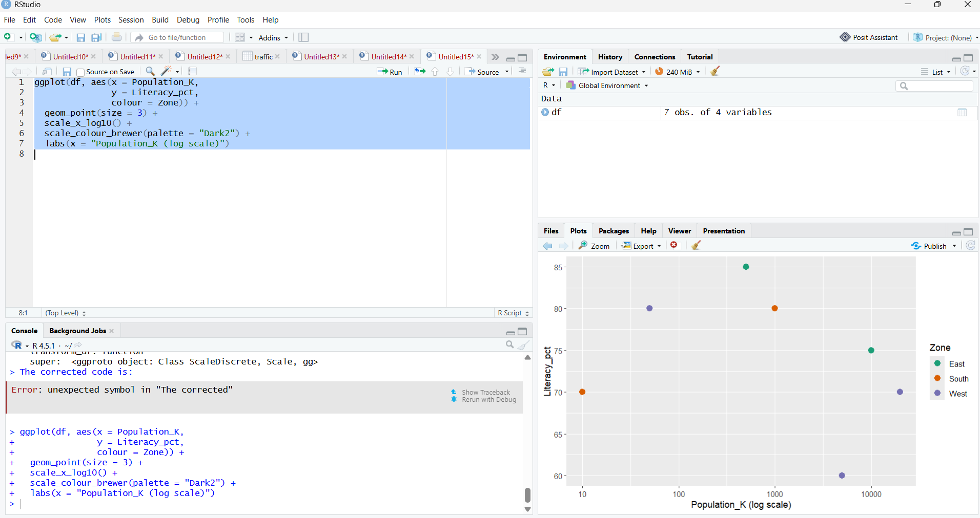
RESULT
Thus, the given data were represented using appropriate ggplot2 aesthetics, colour scales, sequential/qualitative palettes, and logarithmic axes. The visualizations make comparisons and patterns in the data easier to understand.

